Hosted By: |  | Midland Public Schools Midland Mall

What is Canstruction®?
Canstruction® is a unique international 501(c)(3) food charity which hosts competitions, exhibitions and events showcasing colossal structures made out of cans of food. After the structures are built the creations are on display to the public as a giant art exhibition. At the end of the viewing, all food is donated to local hunger relief organizations. Canstruction events have been held in 215 cities world-wide and collected over 20 million pounds of food.

Why is Canstruction happening in Midland?
The Midland County Emergency Food Pantry Network (EFPN), Midland Public Schools and the Midland Mall joined together to bring this world-wide event to Midland. Our community is known for its “people helping people” mindset; this event is a way to increase awareness of food insecurity and the needs in our community. The food used to build the sculptures will be donated to EFPN and distributed to your neighbors in need.

Who is participating in Canstruction Midland?
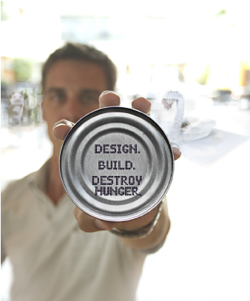
Teams will be announced on February 10, 2020. Students from area high school and middle schools will build transportation-themed sculptures made entirely of canned and boxed food inside the Midland Mall.

How are the sculptures created?
Students will use STEAM principles such as engineering, mathematics, the arts, design and 3D modeling and problem solving to create their designs. Each transportation-themed sculpture will be up to 5 feet long, 5 feet wide, and 5 feet high. Teams will have five hours to create their structures.

Where and when will Canstruction Midland take place?
Midland Mall. The sculptures will be built throughout the Mall on Friday, February 21, 2020 between 8:00 AM and 1:00 PM, and will be on display through Saturday, February 29, 2020. Technical Awards will be announced at 2:30 PM on February 21, 2020 at the Midland Mall Center Court. The People’s Choice Award will be announced at 12:00 PM on February 29, 2020 at the Midland Mall Center Court. Structures will be “de-canstructed” after the People’s Choice Award ceremony and donated to EFPN for distribution to our neighbors in need.

Vote for your favorite at the food court!
$1 = 1 VOTE
Feb. 21-28
Public Exhibition
Feb. 21-29
Midland Mall

What are the award categories?
Technical Awards will be given to the teams with the highest score on structural integrity, best original design and best use of labels. Additional Awards will be given for the People’s Choice and Most Food Items.

How much does it cost to see the structures?
It is free! Bring your family and friends, vote for your favorite sculptures and enjoy the sculptures in the indoor comfort of Midland Mall during mall hours.

How do I sponsor a team or the event?
Email canstructionmidland@gmail.com to learn more about our sponsor opportunities.

About Midland County Emergency Food Pantry Network (EFPN)
EFPN is the largest charitable food provider in Midland County with eight pantries, and additional programs including Backpack Buddies, Thanksgiving Meals, Medical Nutrition, Mobile Pantries and Senior Food Delivery. In 2019, EFPN operations met the needs of 8,154 people through the pantries, 7,998 through mobile pantries, about 1,250 people received a Thanksgiving dinner, and approximately 775 elementary/pre-school students received food each week during the school year through the BackPack Buddies program. We are people helping people.

What is food insecurity?
Food insecurity is the state of not having reliable access to a sufficient quantity of affordable, nutritious food. Access to food is a basic human right, vital for good health and ultimately for life itself. Midland County Emergency Food Pantry Network (EFPN) has been helping the food insecure for over 35 years with vision of "always food in every home".

Is food insecurity really a problem in Midland County?
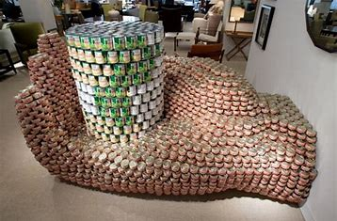
Yes. In 2019, over 35% of calls to Midland County 2-1-1 were for food assistance. The United Way of Midland County reports that 1 in 3 households in Midland County are struggling to meet basic needs, forcing them to make the difficult decision between paying bills and purchasing food for their family. 30% of those in need are not using emergency food resources.

After Canstruction Midland ends, where do the cans go?
At the close of the exhibit, all of the structures are disassembled and the cans are donated to Midland County Emergency Food Pantry Network (EFPN). EFPN’s eight pantries distribute over 17,000 items each month, serving 2,630 households in 2019, representing 8,154 individuals.

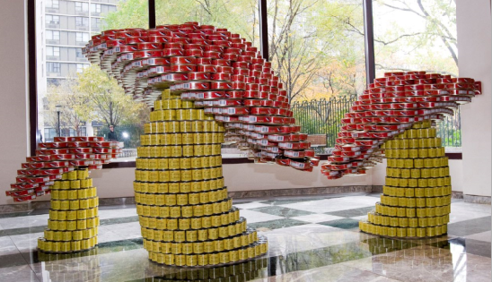
Can I vote for my favorite structure? How many times can I vote?
Yes! The People’s Choice Award may be the most coveted of the prize categories for our student builders! Tickets to vote for your favorite sculpture will be on sale at the Midland Mall food court during mall hours from February 21-February 28, 2020. $1 = 1 vote! Vote as often as you like. The People’s Choice Award will be announced on Saturday, February 29, 2020 at 12:00 PM at the Midland Mall Center Court.

How “CAN” I help fight hunger?
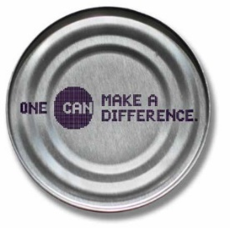
Vote for your favorite structure! Start your own Canstruction Midland fundraising team at https://www.justgiving.com/campaign/canstructionmidland. Host a food drive! Volunteer! Reduce food waste! Tell others about EFPN! Like us on Facebook! Donate online at www.midlandcountyefpn.org! You CAN make a difference!

Is our donation tax deductible?
Yes. Midland County Emergency Food Pantry Network (EFPN) is a 501(c)(3) non-profit organization. You can make a donation online at www.midlandcountyefpn.org or via mail to Midland County Emergency Food Pantry Network, P.O. Box 2521, Midland, MI 48641-2521. All food and financial proceeds from Canstruction Midland benefit EFPN.

I need food. How can I get help?
Call 2-1-1. Don’t go without, we’re here to help.

canstruction.org and midlandcountyefpn.org Facebook.com/canstructionmidland
canstructionmidland@gmail.com

